SWITCH B)

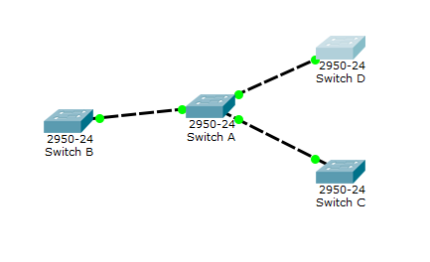

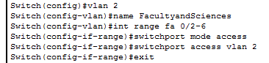

Switch B vlan brief

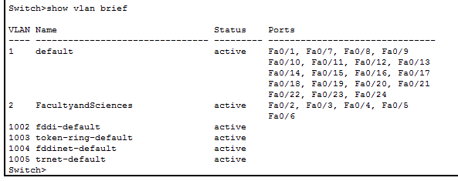

Switch C

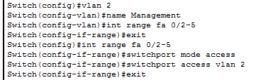

Switch C vlan brief

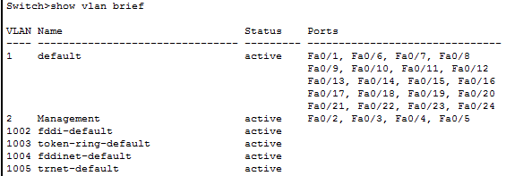

Switch D

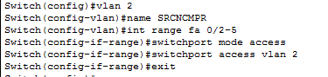

Switch D vlan brief

